Rosanna Cubs – Air Ambulance Trip Tues 28th May

Next Tuesday, the 28th, we’re going to visit the Air Ambulance at Essendon Airport. NOTE: Visit subject to operational requirements of the Air Ambulance Station.

Details:
- Meet at Rosanna Scout Hall – by 6:25pm. (We’ll work out how many cars we need on the spot… parents who can volunteer to provide transport as/if needed will be appreciated – those parents would stay with us for the session if they like).
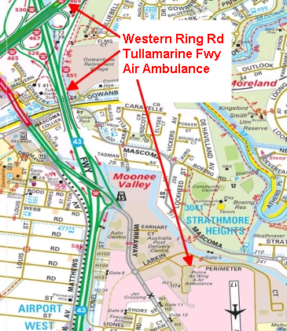
- We’ll then drive to Essendon Airport
  - Air Ambulance is located at Unit 4, 12 Larkin Court, Essendon Fields (Strathmore). See:
https://goo.gl/maps/zDmQ5dLS8n82

- Return to Rosanna Hall will be at approx. 8:45pm (session is due to finish at 8:15.

Regards

Akela (Wayne)
0411 121 495
akela@rosannacubs.org

See us at http://www.rosannacubs.org

Cut off bottom portion of permission slip and return to Leaders prior to departure on Tuesday evening.

Cub Name:________________________________

Emergency Information
In case of emergency, please contact:
Name/Relationship Phone
Special Instructions:

